*On the following pages, you will find a very detailed medical profile questionnaire. Please take the time to fill it out as completely as possible. Every bit of information will assist in formulating a comprehensive and tailored treatment for you. Feel free to use additional sheets as needed. Information requested below is completely confidential and will only be used to determine and tailor the best treatment plan for you. If you have questions, please free to ask.*

Full Name: _______________________________ Name at Birth: _________________

**Personal Information**

Birth Date: _________________ Age: ______

Street Address: ___________________________________________________________

City, State, Zip Code: _______________ E-mail: _______________________

Phones (Home): __________ (Cellular): ___________ (Work): ___________

Emergency Contact: _________________________ Emergency Contact #: __________

How did you hear about us: _________________________________________________

If you heard about us through a friend please provide us their address or email so that we can send them a Thank You card: ____________________________________________

________________________________________________________________________________________________________________________________________________

Have you been treated with acupuncture previously ___Yes ___ No

With whom, what were you treated for, experience and results: ________________________________________________________________________________________________________________________________________________

________________________________________________________________________

Have you been treated with Chinese herbal? ___Yes ___ No

May I send you appointment updates via email/text? ___Yes ___ No

Relationship Status (optional):

___Single ___Married or Partnered ___ Divorced ___ Widowed

Current relationship quality: ____________ Current quality of life: ________________

Date: ______________

Reasons for today’s visit: ___________________________________________________

**Personal Medical History**

________________________________________________________________________

________________________________________________________________________

Please describe the circumstances under which the problem began: __________________

________________________________________________________________________

________________________________________________________________________

What improves and what aggravates the main complaint? _________________________

________________________________________________________________________

________________________________________________________________________

Does this interfere with daily activities, sleep, and/or work? ___Yes ___ No

How does it interfere with the above? _________________________________________

________________________________________________________________________________________________________________________________________________

What other symptoms, if any, are associated with this problem(s)? __________________

________________________________________________________________________

________________________________________________________________________

Describe any previous diagnosis or treatments you have received for this complaint:

________________________________________________________________________

________________________________________________________________________

________________________________________________________________________

What other problems would you like to tackle? _________________________________

________________________________________________________________________

________________________________________________________________________

Please list the specific goals you’d like to accomplish during our time together:

________________________________________________________________________

________________________________________________________________________

________________________________________________________________________

Please describe the level of health you’d like to be experiencing one year from today

________________________________________________________________________

________________________________________________________________________

________________________________________________________________________

Describe any lifestyle changes that you think would help you achieve that goal: ________________________________________________________________________

________________________________________________________________________

________________________________________________________________________

Date: ______________

*Please put a “C” if the sign or symptom is current or a “P” if you had the sign or symptom in the past*

**DETAILED SIGNS AND SYMPTOMS**

**GENERAL**

* Aversion to Cold not improved by warmth
* Fear of Cold improved by warmth
* Chillness of specific body area
* Fever
* Simultaneous fever and chills
* Alternating fever and chills
* Feels too hot
* Feels too cold
* Avoids heat or cold
* Cold hands/feet/both
* Hot hands and feet/both
* Sweaty palms/feet/both
* Morning hot flashes
* Afternoon hot flashes
* Spontaneous sweating
* Frequent sweating
* Night sweating
* Profuse sweating
* Scant sweating
* No sweating
* Sweating of specific body areas
* Generalized pain
* Heavy, tired body
* Paralysis or Numbness
* Tremors or twitching
* Generalized itching
* Jaundice
* Edema
* Unusual weight loss
* Unusual weigh gain
* Fatigue
* Afternoon fatigue
* Low energy
* Sudden energy drops
* Drowsiness after eating
* Bleeding, bruising
* Loss of consciousness
* Feeling worse after exercise
* Feeling better after exercise
* General feeling of body heaviness
* Mental heaviness, sluggishness or fogginess
* Frequent colds/flus
* Intolerant to weather changes

**HEAD and FACE**

* Headache
* Migraines
* Heavy head sensation
* Unusual sensations in the head
* Dizziness or vertigo
* Dizziness with standing
* Fine, thin hair
* Excessive hair loss
* Slight hair loss
* Hair loss with oily scalp
* Dry hair
* Dandruff
* Premature graying
* Change in hair texture
* Hot flashes in heat
* Facial pain
* Facial numbness or Tics
* Facial swelling
* Deviated mouth and eyes
* Jaw pain/TMJ

**EARS**

* Ear ringing
* Itchy ears
* Painful ears
* Discharge from ears
* Hearing impairment
* Hearing loss
* Chronic ear infections

**EYES**

* Eye pain/strain
* Itchy eyes
* Dry eyes
* Red/inflamed eyes
* Burning eyes
* Frequent tearing
* Sensitivity to light
* Frequent floaters/spots
* Night blindness
* Impaired vision
* Blindness
* Blurred vision
* Double vision
* Glaucoma
* Sty
* Swollen or drooping eyelids
* Puffy or darkness under eyes
* Contacts and/or glasses

**NOSE**

* Nose pain
* Nosebleed
* Dry nose
* Runny nose
* Nasal congestion
* Nasal swelling
* Sinus problems
* Nasal obstruction
* Loss of sense of smell
* Peculiar smells
* Sneezing

**MOUTH**

* Bad breath
* Excessive saliva
* Dry mouth
* Oral thrush
* Mouth sores/ulcers
* Bitter taste
* Sweet taste
* Sour taste
* Cracked dry lips
* Lip tremors
* Lip sores
* Tongue disorders: quivering, moving, deviated
* Tongue sores/ulcers
* Loose teeth or toothache
* Extensive dental decay
* Teeth grinding
* Painful, swollen, or bleeding gums
* Jaw clicks/locks
* Difficulty chewing

**THROAT**

* Sore, swollen throat
* Itchy throat
* Dry throat
* Recurrent sore throat
* Frequent throat inflammation
* Sensation of mass stuck in throat without eating
* Difficulty swallowing
* Hoarse voice
* Loss of voice
* Voice change
* Enlarged lymph glands

**MUSCULOSKELETAL/LIMBS**

* Muscular weakness
* Muscular cramps
* Muscular atrophy
* Muscle stiffness
* Muscle twitching
* Muscle spasms
* Spinal column pain
* Upper back pain
* Lower back pain
* Tailbone pain
* Painful back with inability or difficulty to stretch or bend back
* Disc/spinal problems
* Sciatica/shooting pain
* Degenerative disc
* Scoliosis
* Stiff and painful flanks due to falling or sprain or hard physical work
* Dull pains of flanks
* Left kidney area pains
* Right kidney area pains
* Cold sense on the back
* Shoulder pain
* Aching pains of shoulders and back
* Arm pain
* Swollen and painful arm joints
* Four limb stiffness
* Four limb numbness
* Aversion to cold and cold limbs
* Weak limbs
* Cold limbs
* Numb limbs
* Pain in limbs
* Joint instability
* Joint immobility
* Joint stiffness
* Joint pain
* Joint buckling
* Joint locking
* Joint swelling
* Joint swelling and pain
* Degenerative joint disorder
* Inability to turn neck
* Stiff neck
* Neck pain
* Knee pain
* Knee pain and swelling
* Sore, cold, or weak knees
* Lower limb edema
* Lower limb inflammation
* Lower limb varicosities
* Edema of lower limbs
* Swollen and painful leg joints
* Foot or leg tremors
* Foot pain
* Feet swelling
* Toe pain/numbness/weakness
* Hot sense in soles and palms in afternoon or night
* Cold hands and feet
* Feet and hand swelling
* Hands and feet numbness
* Hand swelling
* Hand tremors
* Pale, discolored, thick or deformed fingernails
* Brittle, weak nails
* Finger pain/numbness/weakness
* Broken bones
* Injuries or falls
* Recent sprains
* Tendonitis/bursitis
* Inhibited stretching
* Moving body joint pains
* Heavy sense wrapping body
* General aches
* General body pain
* Edema of general body
* Osteoporosis
* Arthritis

**CHEST, RIB-SIDE**

* Breast lumps, cysts, tenderness, etc.
* Nipple discharge
* Chest pain
* Chest tightness
* Heat or unusual sweating of chest
* Rapid heart beat
* Chest oppression
* Stabbing chest pain
* Tight sensation in chest
* Palpitations- slight/severe
* Poor circulation
* Irregular heartbeat
* Distention/discomfort/pain along sides of trunk
* Fainting spells
* Blood clots
* Unusual armpit odor
* Difficulty swallowing
* Cough
* Coughing blood
* Rapid, labored, hasty breathing
* Wheezing
* Shortness of breath
* Easily winded with exertion when laying down  
  Pain with deep breaths
* Phlegm production
* Difficulty breathing- slight/moderate/severe
* Difficulty inhaling
* Difficulty exhaling
* Pain with deep inspiration
* Frequent yawning

**SKIN**

* Acne
* Dry/oily/sensitive skin
* Itching/rash/hives
* Bruise/bleed easily
* Varicose veins
* General edema
* Fungal infections
* Warts
* Eczema/psoriasis
* Slow wound healing
* Skin disease
* Excessive sweat- day or night
* Body hair loss
* Moles/lumps
* Skin discolorations
* Ulcerations
* Change in skin texture
* Facial flushing

**FOOD AND TASTE**

* Craving for (Flavor):_______
* Present taste in mouth (i.e sweet, bitter, etc.)
* Poor appetite
* Excessive hunger
* Hunger with no desire to eat
* Irregular food intake
* Fatigue after meals

**THIRST AND BEVERAGE INTAKE**

* Excessive thirst
* Thirst unquenched by drinking
* Thirst w/o desire to drink
* Lack of thirst
* Drinking w/o desire to swallow
* Liking for Cold drinks
* Liking of Warm drinks

**GASTROINTESTINAL**

* Stomach pain
* Burning stomach pain
* Cold stomach pain
* Shrinking sense of the stomach
* Dropping sense of the stomach
* Stomachache likes warmth
* Stomachache likes pressure on it
* Pain in area of navel
* Abdominal fullness
* Abdominal swelling (ascites)
* Rumbling intestines
* Hiccups
* Belching
* Belching with sour taste in mouth
* Acid regurgitation
* Nausea
* Vomiting
* Vomiting of blood
* Desire to vomit
* Bloating after meals
* Indigestion
* Gas
* Stomach ulcers
* Gallstones
* Hernia
* Lower abdominal distention
* Lower abdominal pain
* Lower abdominal pain likes warmth and pressure
* Diarrhea worse after emotional frustration or distress
* Diarrhea every 5 am with abdominal pains
* Dysentery
* Constipation
* Alternating constipation with diarrhea
* Intestinal pain/cramping
* Rectal pain/itching
* Rectal prolapse
* Anal fissures
* Hemorrhoids
* Laxative use
* Parasites

**Bowel Movement:** *Fill in Blank and Circle*

Number of BM’s a day: ______________  
My stools are: Soft Loose Hard Dry Watery

Normal Small bitty Difficult Require straining Burning Foul odor With mucus/blood/Undigested Food

Lt brown Dark Pale Green Red Green-blue Pale/dark yellow Very dark black

Odor of stool: None Strong foul Sour smell

**UROGENITAL**

* Pain with urination
* Pain before urination
* Pain after urination
* Profuse urination
* Scanty urination
* Spasms during urination
* No sense of need to urinate
* Waking to urinate at night
* Poor bladder control
* Dribbling urination
* Dribbling after urinating
* Inability to hold urine
* Bedwetting
* Urinary retention
* Frequent urinary infections
* Genital pain or itching
* Genital sores
* Kidney or bladder stones
* Frequent daytime urination
* Frequent night time urination

**Urination:** *Please Circle*

Color is: Yellowish Bloody Very pale Dark yellow Reddish Soy sauce like

Urine is: Clear Cloudy

Any: Burning Pain Difficulty Urgency

Urine smell is: Non Foul Sweet

Number of times I urinate on a daily basis is _________________.

**SLEEP**

* Sound/restful sleep
* Insomnia
* Difficulty falling asleep
* Difficulty staying asleep
* Wakes easily
* Waking too early
* Daytime sleepiness
* Day dreaming
* Profuse dreaming
* Vivid/disturbing dreams
* Excessive snoring
* # of hours sleep/night: ________
* Excessive sleep
* Difficult waking

**MENTAL-EMOTIONAL**

* Optimistic, open-minded, happy
* Relaxed/calm
* Pessimistic
* Melancholic
* Always worried
* Excessive worry/over thinking
* Easily worried/ overwhelmed
* Obsessive/compulsive
* Lone and closed minded
* Often depressed
* Sad/Grief/Depressed
* Persistent sorrow
* Frequent crying
* Cry uncontrollably
* Anxiety
* Feelings of claustrophobia
* Manic
* Panic attacks
* Agitation
* Often nervous
* Fearful
* Terrors
* Insecure/paranoid
* Easily startled
* Stressed
* Impatient
* Mood swings
* Irritability/frustration
* Easy to anger/often angry
* Nervous laughter
* Timid/low self esteem
* Cognitive impairment
* Forgetful/Poor memory
* Trouble concentrating
* Impaired speech
* Mentally restless
* History of abuse
* Considered/attempted suicide
* Low motivation/lack of will power

How are you feeling today? _________________________________________________

Have you ever been diagnosed with any mental illness? If so, what? _________________

**FOR MALES ONLY**

*Please check as appropriate*

* Impotence (Erectile dysfunction)
* Weak erection
* Tiredness and dizziness after ejaculation
* Pain, swelling, itching or discomfort of genitals
* Feeling of coldness or numbness in external genitalia
* Perineum pain
* Burning sense in urethra
* Penile discharge
* Strong genital smell
* Sexually Transmitted Disease
* Enlarged prostate
* Dropping sense of anus
* Sterility/infertility
* Number of children: ______

*Please circle the correct answer and fill in the blanks*

Libido: Normal None Low Excessive

Ejaculation: Unable Premature

Emissions during: Daytime Nighttime

Frequent masturbation: 1-2 years 2-4 years > 4 years

Testicle pain: one side both sides

Scrotum: Swollen Cold damp Damp hot Itching

Last PSA result: ______ Last prostate exam: _________ Result: ____________

**FOR WOMEN ONLY**

*Please answer each question or check as appropriate*

Are you pregnant, or is there any chance you may be pregnant? ___Yes ___ No

# of pregnancies: _______ # of births: _______ # of live children: _______

# of premature births: ________ # of miscarriages/abortions: _______

Year of last pregnancy: _______ What issues, if any, did you have during last pregnancy? ______________________________________________________________

________________________________________________________________________

Did you or do you have difficulty conceiving? ___Yes ___ No

Age of first menses: ____ Last menstrual period: ______

Regular cycles: ___Yes ___ No Number of days between periods: ________ Average days of flow: _____ Do you bleed between periods? ___Yes ___ No

*Circle the correct answer*

Blood flow is: Normal Heavy Light

The blood color is: Normal Dark Red Pale Bright red Brown Purple

I would describe my menstrual blood as *(circle the correct answer):*

|  |  |  |  |
| --- | --- | --- | --- |
|  | Clotted with dark dull clots |  | Watery blood |
|  | Clotted with dark, fresh looking clots |  | Sticky blood |
|  | Large dark clots |  | Thick blood |
|  | Small dark clots |  | Thin blood |
|  |  |  | Normal |

What, if any, signs/symptoms do you experience around your menstrual cycle each month? Identify if you experience them before, during, or after your period.

|  |  |  |  |
| --- | --- | --- | --- |
|  | Before | During | After |
| Breast distention |  |  |  |
| Breast distention with tenderness |  |  |  |
| Irritability |  |  |  |
| Propensity to angry outbursts |  |  |  |
| Weepiness |  |  |  |
| Depression |  |  |  |
| Nausea and vomiting |  |  |  |
| Food  cravings |  |  |  |
| Craving for sweets |  |  |  |
| Constipation |  |  |  |
| Diarrhea  Edema/Water retention |  |  |  |
| Pain/cramping |  |  |  |
| Low back pain |  |  |  |
| Body aches |  |  |  |
| Fatigue |  |  |  |
| Headaches |  |  |  |
| Insomnia |  |  |  |
| Fever (objective or subjective) at time of period |  |  |  |
| Nosebleed |  |  |  |
| Coughing blood |  |  |  |
| Mouth ulcers |  |  |  |
| Skin eruptions |  |  |  |
| Dizziness |  |  |  |

Do you have unusual vaginal discharge between periods? If yes, describe vaginal color, consistency (thick or watery), odor: ___________________________________________

________________________________________________________________________________________________________________________________________________

Current contraception used: ____________ Past contraception used: __________

Do you use tampons or pads? _____________

Age at menopause: _________

Currently on Hormone Replacement Therapy (HRT)? ___Yes ___ No

Name/Dose: _____________________________________________________________

How long have you been on HRT? ________ Any side effects? ___Yes ___ No

Date of last PAP smear: ­­­­_________ Result: Normal Abnormal

*Please place a check mark to identify any other relevant history*

|  |  |  |  |  |  |
| --- | --- | --- | --- | --- | --- |
| Menopausal symptoms/hot flashes |  | Cervical dysplasia |  | Excessive vaginal discharge |  |
| Reduced or lack of libido |  | Ovarian or uterine cysts |  | Vaginal dryness |  |
| Strong sexual desire |  | Endometriosis |  | Vaginal sores |  |
| Reduced sexual desire |  | Hysterectomy |  | Difficult intercourse |  |
| Headache soon after orgasm |  | Burning sense in womb |  | Vaginal bleeding after menopause |  |
| Breast lumps |  | Womb prefers warmth and pressure |  | Profuse and sudden uterine bleeding |  |
| Fibrocystic breast tissue |  | Cold sense in womb |  | Gradual uterine bleeding |  |
| Uterine fibroids |  | Sense of womb dropping |  | Sexually Transmitted Disease |  |
|  |  |  |  | Frequent yeast infection |  |

Other: __________________________________________________________________

________________________________________________________________________

*A. Draw today’s symptoms on the figures.*

**PAIN AND SENSORY PATIENTS**

*If you are coming in for physical pain or sensory issues, please fill out this section.*

*Please identify the area of pain by placing a circle on that area and then write the number you would rate the pain at within that circle. “0” indicates “no pain”, “10” indicates the “worst pain ever felt”.*

*Next, describe what you feel in the margins. Words used to describe pain can be deep ache, tight, pinching, sharp, stabling, burning, constant, pinprick, cramping, pressure, electrical sensations, pins and needles, numbness, tingling. Indicate where your pain radiates.*

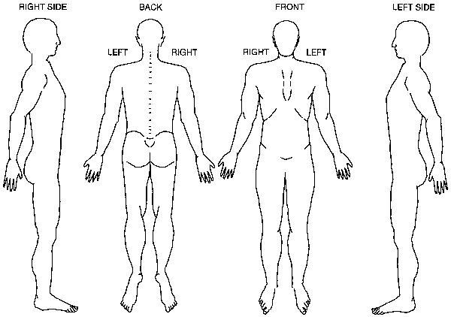

**HEADACHE AND FACIAL PAIN**

*Please identify the area of pain by placing a circle on that area and then write the number within that circle. Please describe what you feel in the margins. Words used to describe pain can be deep ache, tight, throbbing, sharp, stabling, dull ache, constant, pinpricks, heaviness, etc…*

Front Back Right Side Left Side

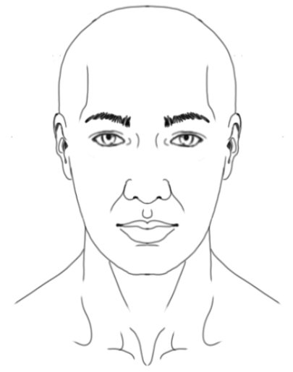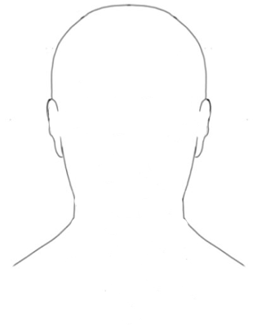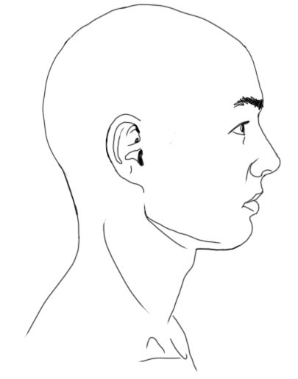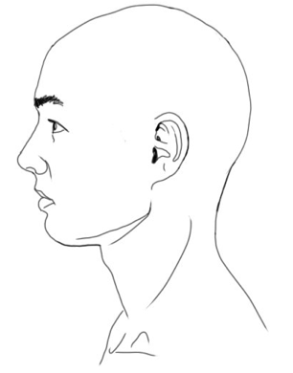

What time of day does it get worse? _____ What time of day does it get better? _____

Is it constant? ____Yes____No Does it come and go? ____Yes ____No

Is it hot to touch? ____Yes ____No Is it cold to touch? ___Yes ___ No

Do you take anti-coagulants (i.e. blood-thinning medication) or Lithium? ___Yes ___ No

**MEDICAL HISTORY**

Do you have an electronic implants (i.e. pacemakers, deep brain stimulators, etc.…) or have any condition that may contraindicate electro-stimulation treatment? If yes, what device (s) do you have implanted? _______________________________________________________________________

Do you have any implants or prosthetics? If so, please describe: ____________________

_______________________________________________________________________

Do you receive Botox injections? If yes, where? ______________________________

How would you rate your energy level right now? (scale of 1 to 10)

Great Ok Bad

10----------------5------------------1

What time is your energy level the highest? ______________

What time is your energy level the lowest? ___________________

How committed are you to getting well? 0%----------50%-------------100%

Occupation: ______________ Stress Level (from 1-10): ________

Favorite time of year: __________ Worst time of year: ___________

Describe your health as a child: ______________________________________________

Describe your health now: __________________________________________________

*Please identify medical conditions that pertain to of the family members below by placing an “X” in the appropriate box(es)*

|  |  |  |  |  |  |
| --- | --- | --- | --- | --- | --- |
|  | **Self** | **Father** | **Mother** | **Brother(s)** | **Sister(s)** |
| Age (if living) |  |  |  |  |  |
| Health (G=Good, P=Poor) |  |  |  |  |  |
| Addictive disorders |  |  |  |  |  |
| AIDS/HIV |  |  |  |  |  |
| Allergies |  |  |  |  |  |
| Arthritis |  |  |  |  |  |
| Arteriosclerosis |  |  |  |  |  |
| Asthma/COPD/Breathing Issues |  |  |  |  |  |
| Autoimmune Disorders |  |  |  |  |  |
| Bladder Issues |  |  |  |  |  |
| Breast Issues |  |  |  |  |  |
| Blood or bleeding disorders/anemia |  |  |  |  |  |
| Cancer/Tumors |  |  |  |  |  |
| Chronic Fatigue |  |  |  |  |  |
| Chronic Pain |  |  |  |  |  |
| Diabetes |  |  |  |  |  |
| Diverticulitis/IBS/Crohn’s |  |  |  |  |  |
| Eating Disorders |  |  |  |  |  |
| Epilepsy |  |  |  |  |  |
| Excess Phlegm |  |  |  |  |  |
| Eye Disorders |  |  |  |  |  |
| Fibromyalgia/Polymyalgia |  |  |  |  |  |
| Fungal Infections |  |  |  |  |  |
| Gastritis |  |  |  |  |  |
| Headaches |  |  |  |  |  |
| Heart disease |  |  |  |  |  |
| Hepatitis |  |  |  |  |  |
| Herpes |  |  |  |  |  |
| High Cholesterol |  |  |  |  |  |
| HIV/AIDS |  |  |  |  |  |
| Hyper/hypoglycemia |  |  |  |  |  |
| Hyper/hypotension |  |  |  |  |  |
| Hysterectomy |  |  |  |  |  |
| Impotence |  |  |  |  |  |
| Infertility |  |  |  |  |  |
| Kidney Disorders |  |  |  |  |  |
| Laxative Use |  |  |  |  |  |
| Liver/Gallbladder Disease |  |  |  |  |  |
| Lyme Disease |  |  |  |  |  |
| Mental Illness |  |  |  |  |  |
| Musculoskeletal Disorders |  |  |  |  |  |
| Neurological Disease |  |  |  |  |  |
| Rheumatic Fever |  |  |  |  |  |
| Seizures |  |  |  |  |  |
| Skin Issues |  |  |  |  |  |
| Stroke |  |  |  |  |  |
| Tonsillitis |  |  |  |  |  |
| Thyroid Disorders |  |  |  |  |  |
| Ulcers |  |  |  |  |  |
| Vein Conditions |  |  |  |  |  |

**Major Hospitalizations:**  *Write down hospitalizations for any serious medical illness or surgeries. Do not include any normal pregnancies.*

|  |  |
| --- | --- |
| **Operation/Illness** | **Date** |
|  |  |
|  |  |
|  |  |
|  |  |
|  |  |

**Significant Traumas**

*Please list accidents, disasters, death of loved ones, birth trauma (i.e prolonged labor, forceps delivery, etc)….dates*

|  |  |
| --- | --- |
| **Trauma** | **Date** |
|  |  |
|  |  |
|  |  |
|  |  |
|  |  |

**Medications/Herbs/Supplements/Recreational Drugs**

*Please list all prescriptions, over the counter medications, herbs, supplements, and recreational drugs you currently take. Please attach a separate sheet if needed to complete the medication list*

|  |  |
| --- | --- |
| **Medications/Herbs/Supplements/Drugs**  **Frequency, Dosage** | **Reason for Taking** |
|  |  |
|  |  |
|  |  |
|  |  |
|  |  |

Please list all allergies (i.e. medications, foods, animal dander, etc.): *________________*

*________________________________________________________________________*

*________________________________________________________________________*

Height: __________ Weight: __________Stress level (1-10): __________

**Personal Lifestyle Habits**

Hours of exercise per week: __________

What type of exercise do you do? ____________________________________________

What non-work activities do you enjoy (reading, gardening, TV, meditation, etc….)

________________________________________________________________________

Living environment (circle one): cold and windy damp dry hot

Please describe your typical meals:

Morning _____________________________________________________________

Afternoon ____________________________________________________________

Evening ______________________________________________________________

Snacks _______________________________________________________________

What foods have you been craving lately_______________________________________

Preferred tastes: Bitter Spicy Sour Salty Sweet

Please identify the amount of each below:

Coffee/Tea (cups/day): ______ Energy drinks (oz/day): _____

Alcohol (drinks/week): _____ Tobacco products: _____

Have you ever used tobacco products? If so, when did you quit? How much tobacco product did you use a day? __________________________________________________

________________________________________________________________________

Are you exposed to second hand smoke on a daily basis? _______________